**Not a Banana**

A game by Nadia Leshenko

**Table of Contents**

Summery: 3

Story: 3

Gameplay: 3

Additional Mechanics: 4

Player Abilities: 4

Goal: 5

Loosing: 5

Controlls: 5

Level Design: 6

Screens Wireframes: 9

Art Style: 12

Sound: 12

Assets Required: 13

Inspiration: 22

Finding the Idea for the Game: 22

About the Game’s Name: 22

Summery:  
“Not a Banana” is a single player 2d side-scroller puzzle-adventure pc game.  
In a world where humanity has wiped from existence due to a big flood, only few small animal species had survived and now living in this ruined world.  
The game follows the story of an old mouse and his boat, far away from home, trying to survive after this end of the world.  
Armed with a needle, the mouse is popping objects full of water in order to move his boat and advance in his journey.  
One step at a time, the mouse gets closer to his home.  
After each object pops, the waters rise, taking the boat and the mouse with them and getting them closer to the exit for each level.  
Each level features a collection of ideas the player has to explore in order to progress in the game.

Story:  
Our story takes place after a big flood that wiped humanity from existence.  
The world is dark and most things are broken and soaked with water.  
It’s hard to find any living life forms and plants and animals that live in water are prosperous.  
Animal species that had survived are mice, rats, roaches, few bug species and single-celled organisms mostly.  
The game follows the story of an old mouse trying to survive and get back home.  
The only 2 things he has with him in this journey is his trusty old boat and a needle.

Gameplay:  
The game is a 2d side scroller puzzle-adventure game.  
It follows the story of an old mouse trying to survive at the end of the world.  
He has a boat and is armed with a needle.  
With the needle, he pops objects to extract water from them.  
The water that is leaking out of these object is filling the world beneath him.  
As the waters rise, the mouse and the boat follows.  
The game is level based.  
Each level is made out of an “invisible” grid of squares.  
Objects marked with 1 drop are leaking enough water to fill one row of squares.  
Possible marks on objects vary from 1 drop to 3 drops.  
The number of rows needed to be filled with water in order to reach the exit varies from each level.

Additional Mechanics:  
- Some objects cannot be popped with a “default” needle, but require a different needle found in the level itself.  
- The player can lose the needle by having some flying bug taking it away, making him unable to pop objects and finish the level.  
- The player loses his needle (story driven) and has to solve few puzzles without it.  
In this case, the water rises independently, and the player has to make it in time to the exit before he passes it.  
- Some objects will leak green-colored liquid that can’t fill the word like water, but can fill different containers like barrels. Not filing that barrel with the green liquid will fail the level since the water level won’t rise enough to reach the exit.  
- The water level will be lowered over time due to some other (probably dying) animal or a plant drinking it.  
- Some objects can only be popped after activating a specific button.

Player Abilities:  
The player controls the mouse, and the boat when the mouse is in it.  
  
The mouse can do the following things:  
• Move left and right  
• Jump low  
• Look up and down (scrolling the screen in the direction he looks)  
• Pop water and other liquid-leaking objects with his needle  
• Click on buttons to activate things  
  
The boat can do the following things:  
• Move left and right on water.

Goal:  
The player’s goal is to get the main character with his boat to the exit of each level, which is usually located at the top of the screen.  
He achieves that by popping objects that are leaking water which fill the world beneath him, making the mouse and the boat get higher and higher.

Loosing:  
The most common way to lose a level is by failing it.  
That means, the player can block the exit and he will have to restart the level.  
For example: he can extract more water than the amount needed to reach the exit and pass it, and since the mouse cannot swim, he can’t reach the exit.  
Less common, and more stupid way of losing a level, will be leaving the boat when there’s no ground to stand on, and drowning.  
On a level having its water level decrease over time, it is possible to fail the level by simply not getting to the exit fast enough.  
The main character can get killed from getting hit by other animals or creatures lurking inside the level.

Controlls:  
A,D – character left and right movement  
E / Left Mouse Button – interaction (popping objects, clicking on buttons, etc..)  
W / cursor movement up – look up (screen scrolling up and revealing more of the map)  
S / cursor movement down – look down  
Spacebar – jump

Level Design:  
The games is based on levels.  
Every level is a collection of ideas as a form of communication between the game designer and the player.  
The ideas in the first levels are gonna be simple, to make sure the player understand the main mechanic of the game, yet those early levels won’t be too easy, clarifying that the game is not going to be easy at all.  
  
Each mechanic should be usable in multiple variations and in different situations.  
If a mechanic can only be used once, the mechanic ain't good.  
  
Every level has at least few different mechanics.  
Taking this in mind, each level acts like a tutorial for himself.  
That means, the player will engage one mechanic in a level, exposing him to this mechanic, and later in the level he will meet the same mechanic but with a twist.  
Each level will mostly feature one new mechanic, with different variations for mechanics seen in previous levels.

Let’s have a look at the first level of the game:  
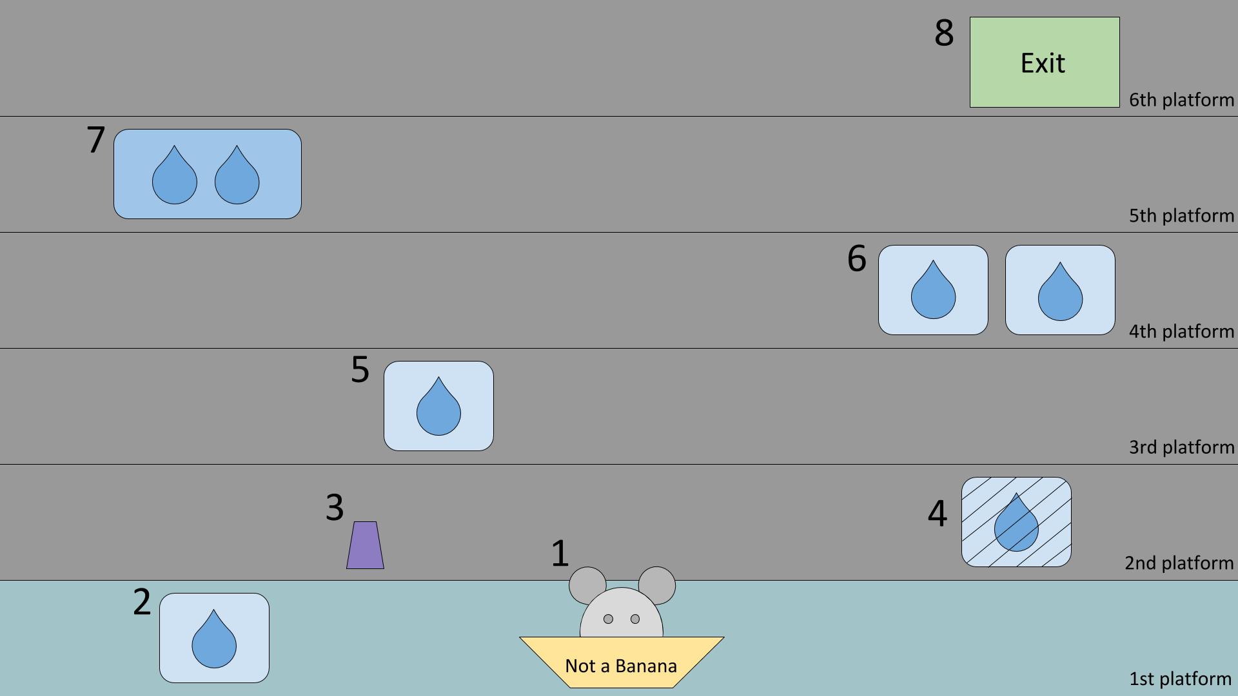  
  
This is the first level of the game as seen in the paper prototype.  
In this level the player learns two mechanics: The main mechanic of the game and one additional mechanic.  
  
Let’s understand what we see here:  
**(1)** This is our main character, the mouse, the hero. He is sitting inside his boat, floating on the water.  
**(2)** This is a water-leaking object, marked with 1 water drop. The player will move the character towards this object and pop it with the needle.  
After doing so, the water level rises, locating the mouse and his boat at the 2nd “platform”.  
**(3)**Once reaching the second platform, he notices a new object, a switch.  
To his right **(4)** is an object he already seen before, but something has happened to it, he is unable to pop it.  
Now the player activates the switch and the water-leaking object he couldn’t pop before is now poppable. So he pops it.  
The water rises again and the player finds himself at the 3rd platform.  
**(5)** Nothing new on this platform, he has already seen this object on the first platform and knows what to do. He pops it!  
**(6)** Now reaching the 4th platform, but this part is a bit tricky, so listen carefully.  
There are two objects to pop, each is marked with 1 drop.  
If the player pop just one of the two objects, he will reach the 5th platform, but will get stuck because on the fifth platform **(7)** there is just one object, but with two drops! If he will pop the water will rise twice and he will miss the exit.  
So, what he should do on the fourth platform is to pop both 1-drop object, making the waters rise the the 6th platform **(8)** and reaching the exit.  
Screens Flow:  
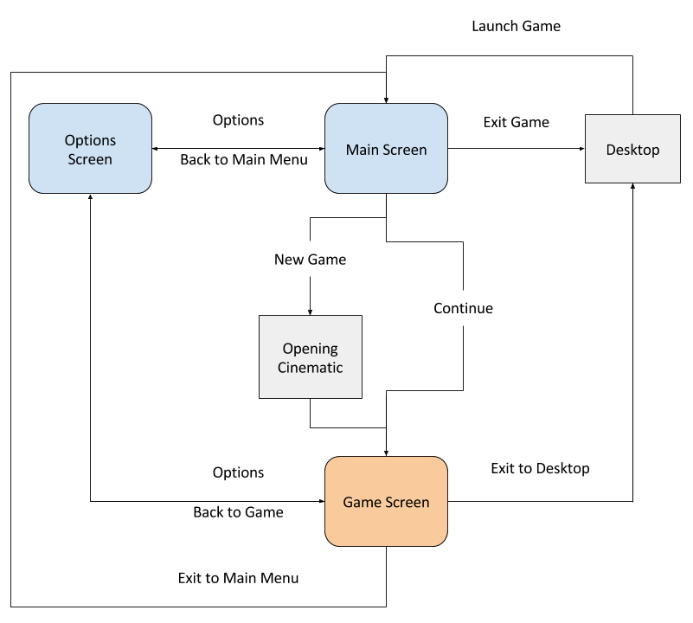

Screens Wireframes:  
  
Main Screen:  
  
  
This is the main screen of the game and it’s the first thing a player sees after clicking that exe file.  
  
Let’s have a look at the actions we can take from here:  
Continue: continue playing from where you left off. The game auto saves at the start of each level.  
New Game: Start a new game. This is leading to the opening cinematic as well.  
Options: Brings you to the options screen.  
Exit Game: Returns to the desktop.  
  
In it’s background we will have some animation featuring the mouse and his boat.  
Needless to say, the background will be interactable – clicking on the mouse for example will make him squeak and turn his head.  
  
  
Options Screen:  
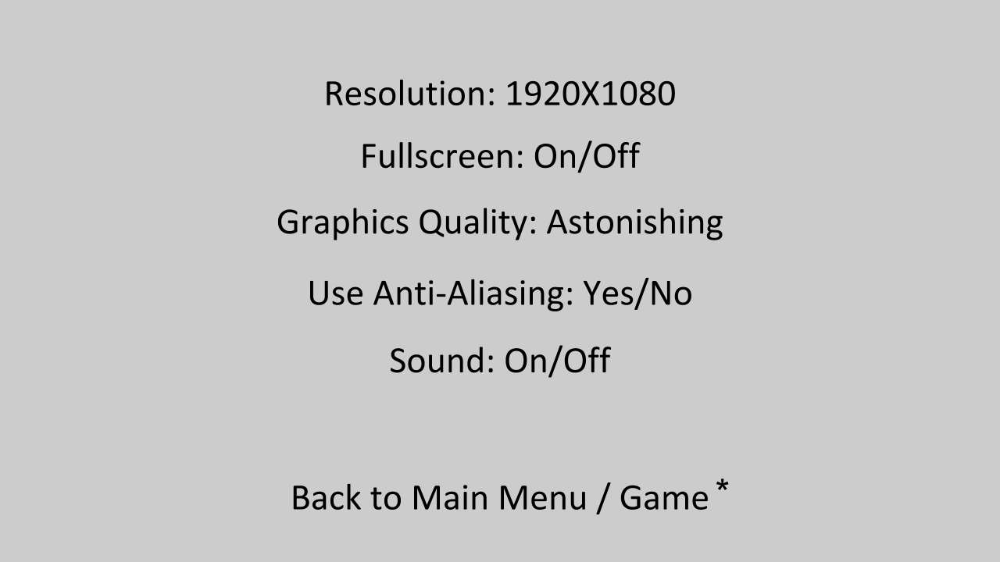  
  
This screen contains the minimum required graphic and sound options for the game such as screen resolution, fullscreen on/off, graphics quality, anti-aliasing and sound.  
  
* “Back to Main Menu / Back to Game” options depends on the previous screen the player has visited.  
If the player has reached the options screen through the main screen, he will see the option “Back to Main Menu”.  
If the player reached the options screen through the game screen, he’ll see the option “Back to Game”.  
  
  
  
  
  
  
  
Game Screen Options:  
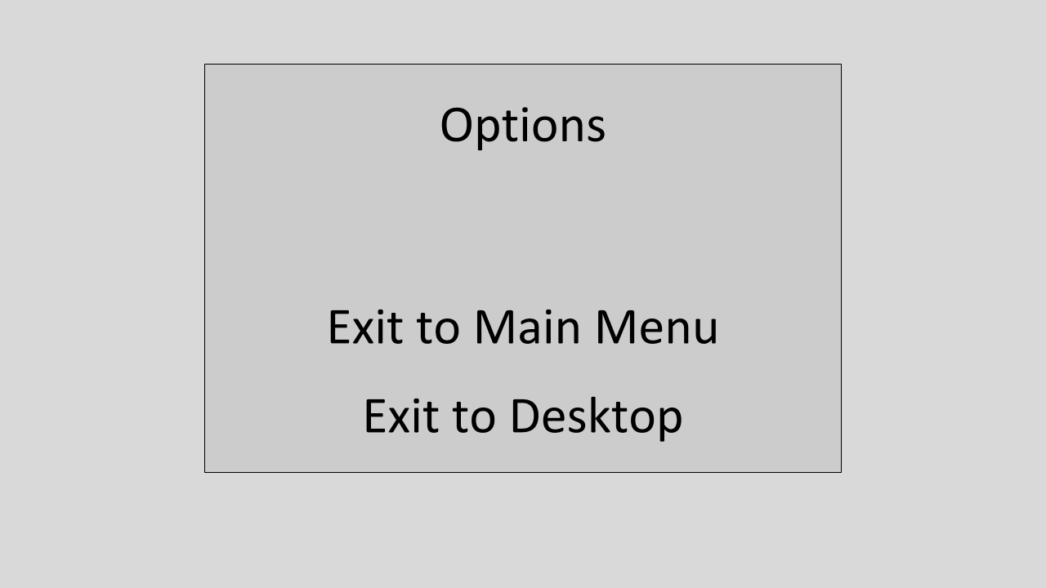  
  
This screen is accessible by pressing “Esc” while in the game screen.  
Doing so, will pause the game and pop up a small floating screen.  
  
In this screen we can take the following actions:  
Options: This will bring us to the options screen.  
Exit to Main Menu: This option will get us to the main screen.  
Exit to desktop: This will exit the game completely, returning the player to his desktop.  
  
Pressing “Esc”, while viewing this screen, will get the player back to the game.  
  
Other than this small options menu, the game screen itself doesn’t contain any GUI. This ensures that the player is focused on the game and it also makes the story more believable. No health bars, no hearts, no minimap, no hints, aside what the player can see on screen – as the main character who has just survived a big flood and has no idea where he is or where the way back home is.

Art Style:  
The game is a semi-realistic 2d side-scroller.  
The story is being told from a mouse’s perspective, everything that for us, humans, is small and unimportant, is big and sometimes scary for a small mouse.  
This world has no living humans at all, and you’re most likely to sometimes see mice, rats and roaches, along with some other small animals that are most likely to survive a big flood, though this is rare as well.  
Apart from that, the environment is consisted of broken houses, dead trees and plants, some animals corpses and sometimes even dead human bodies.  
This world is not cheerful or happy, it’s dark and chaotic, almost all of it is dead and there’s water everywhere you step.  
We can create the desired feeling using desaturated, cold, dark colors and dark or even black outlines.  
Lines are usually sketchy or shaky.  
The shadows aren’t very smooth or soft, but a little rough.  
Warm colors are used very rarely, most likely on the hero, the mouse, and his boat.  
Light in this game is dim, and most of the time is cold as well.  
The level of detail is high in the main character and in the background as well.  
  
References for the art can be seen in games like “Darkest Dungeon”, “Don’t Starve” and more.

Sound:  
The music is slow, and sometimes depressing.  
Using mostly violin and a sometimes a piano as it’s main instruments.  
Most sounds are big, wet and unclear, reminding the player that he (the hero) is small creature in a destroyed world.  
Sounds like footsteps, rain, doors squeaking and so on, will sound big to empower this feeling.

Assets Required:

|  |  |  |  |  |  |
| --- | --- | --- | --- | --- | --- |
| **Name** | **Type** | **Screen** | **Technical Details** | **Quantity** | **Description** |
| Main Screen Background Animation | Animation | Main Screen | Max resolution should be 4k, with options for lower resolutions as well | 2-3 animations for the background, 3-4 animations for the hero mouse | The animation features the mouse in his boat, floating on dirty water, probably from a sewer. Background animation can be water flowing, leaves flying in the wind, windows opening and closing etc.. One mouse animation should have him turning his head towards the screen. |
| Main Game Font | Font | All Screens | Needs to have normal, bold and italic versions, and numbers as well | 2 normal version, 1 of each other versions | The font should be brownish with dark or black, jagged edges. The font should also fit the main artstyle of the game (see Art). |
| Pop-Up Window | GUI | Game Screen | Should be a rectangle, a bit smaller that the screen resolution itself (see Game Screen Options for scale) | Just 1 | The rectangle is made of something that reminds wood, but not completely. It has scratches and cuts and is dull and probably a bit wet as well. |
| Options Screen Animation | Animation | Options Screen | Max res should be 4k with option to lower resolutions as well | 1-2 variations | The animation will feature the mouse, walking and climbing around the screen, saying hello while facing the the player or even knocking on the monitor. |
| Mouse, the main character | Game Object, Animation | Game Screen | Should fit in a square, around 1/8 of the screen resolution | 2 walk animations, 3 popping objects animations, 1 jumping animation, 1 drowning animation, 1 death animation, 2-3 idle animations (one of them is the mouse sitting in the boat). Should have the needle and the boat as an asset apart from the animations as well | The main character is a mouse and he always had his needle with him. The needle looks big compared to the mouse. He walks on two legs and sometimes uses his needle as a walking cane. He doesn’t really need to, but he does it anyway. He is old yet not and elder, he is able to jump and walk as fast as when he was younger. He cannot swim, so if he will come in touch with deep waters, he will drown. |
| Water-Leaking Objects | Game Object, Animation | Game Screen | Different sizes and shapes, according to the object itself. Can fit a square or a triangle in different variations, but not larger than 1/6 on the screen resolution. | 10 or more objects | Objects that you are likely to see after a mass destruction of humanity, that also can contain water. Objects perfect for this description would be dead plants, human trash like sponges, ruined cloth, rotten fruits and vegetables and so on. The objects needs to fit seamlessly in the background. |
| Water Drops | Game Object, Animation | Game Screen | Smaller than the objects leaking water, but not to small. Should be big enough to notice the drops and how many of them are falling | 2-3 variations for each of number of drops falling (1, 2 and 3 drops). Also a color variation for each of the above in green. | Light blue, desaturated, water droplets. The don’t shine or glow, lightning is very minimal. The green liquid may be radioactive or “sewers” green. |
| Level Exit | Game Object | Game Screen | Should be around the size of the main character, a little bit bigger | 3 variations | The level exit is a random mouse-sized door that isn’t connected to any walls of objects in order to draw attention. |
| Water | Game Object, Animation | Game Screen | Should be the same resolution as the wide level backgrounds (see Level Backgrounds) | 2 color variations, one for water and one for green liquid | Water as seen in the Main Screen Background Animation. |
| Buttons | Game Object | Game Screen | Smaller than the main character, around half of his size | 3 different buttons | A button to activate each of the following: Water-leaking objects, level exit and green liquid-leaking objects. Buttons can be some kind of object that hints the thing they activates. |
| Level Backgrounds | Game Object, Animation | Game Screen | Should be in 4K as max resolution, with smaller resolutions versions as well. Some backgrounds will be taller or wider, in different resolutions from one another. | 10 different backgrounds, at least 5 of them are taller and 3 of them are wider. | Should be all set within the same world but not at the same location. Background animations can be things like leaves, doors and windows moving in the wind, some small animal passing through, cables hanging, water wheels and so on. Basically animating everything in the background that needs to move. Check Story and Art. |
| Main Menu Theme | Music | Main Screen | 1-2 minutes, loop | 2 variations | The music should be giving you the feel of coldness and loneliness, even though the game isn’t taking place in the winter. The music should fit the image of our hero mouse in it’s boat, floating to wherever he can get. |
| Hovering Over Options | SFX | All Screens | 2 seconds | 2-3 variations | Something that sounds like a fast “swoosh”. |
| Options Menu Music | Music | Options Screen and Game Screen Options | Around 1 min | Just 1 | More cheerful music then the main menu theme music. The player leaves the game and the story to have a look at the options. This music should not be dark, sad, or depressing. Think of it like a track you’d use for an idle. |
| Game Music | Music | Game Screen | 2-3 min, loop | Around 5 different tracks, adaptive if possible | Sometimes sad or even depressing, depending on the level. The music should bond the player with the main character, the mouse, and his story, and make him relate to him as well (see Story). |
| Objects Popping | SFX | Game Screen | 1-2 seconds | 4-5 variations of different kinds of objects | Possible objects can be dead plants, human trash like sponges, ruined cloth, rotten fruits and vegetables and so on. |
| Falling Water Drops | SFX | Game Screen | 1-2 seconds long | A sound for each number of drops falling: 1, 2 and 3 drops. 1-2 variations for each sound on different surfaces | Imagine how a mouse would hear a water drop falling on different surfaces: cement, wood, ground. |
| Mouse Footsteps | SFX | Game Screen | Around 2 seconds | 1-2 variation for each surface | Small, slow footsteps of an old mouse walking on two legs. You can hear his nails hitting the ground. Surfaces he will walk on will be: cement, wood, ground. |
| Boat Floating on Water | SFX | Game Screen | Around 3 seconds, loop | 2 variations | Sound of a wooden boat floating on water. |
| Mouse Talking | Voice Acting | Game Screen | Length depends on the line | 2-3 variations for each line | Voice lines include: “I can’t do that”, “It’s too far away”, “I can’t jump that high”, “I wish I was home right now”, “Is this the right way?”, “I bet I can pop that”. |

Inspiration:  
The game is inspired mostly by Jonathan Blow and his games - Braid and The Witness, and his approach to puzzle games.  
Long story short, he sees the player as an intelligent person, and doesn’t believe in heavily tutorialized games.  
He sees each level as a collection of ideas the player explores.  
Each level is a way of the designer to communicate with the player.  
The game is inspired as well by games like Super Meat Boy and FEZ, and their creators.

Finding the Idea for the Game:  
The main idea of the game came to me after participating in this year’s Global Game Jam.  
The theme for this GGJ, as we all know, was waves.  
It wasn’t one of the ideas we thought about for our GGJ game, but it was something that came after getting all those ideas up.  
What I thought to myself in that moment was “A game where you pop objects with a needle and water is coming out of them that fills a world so you can, with a boat, reach the exit at the top”.

About the Game’s Name:  
The game’s name, “Not a Banana”, is a temporary name, and will probably be replaced upon release or even in computer prototyping.  
It comes from early stages of paper prototyping this game, where the boat was yellow and reminded the shape of a banana.  
  
If you ever wanted to ask but was too shy.